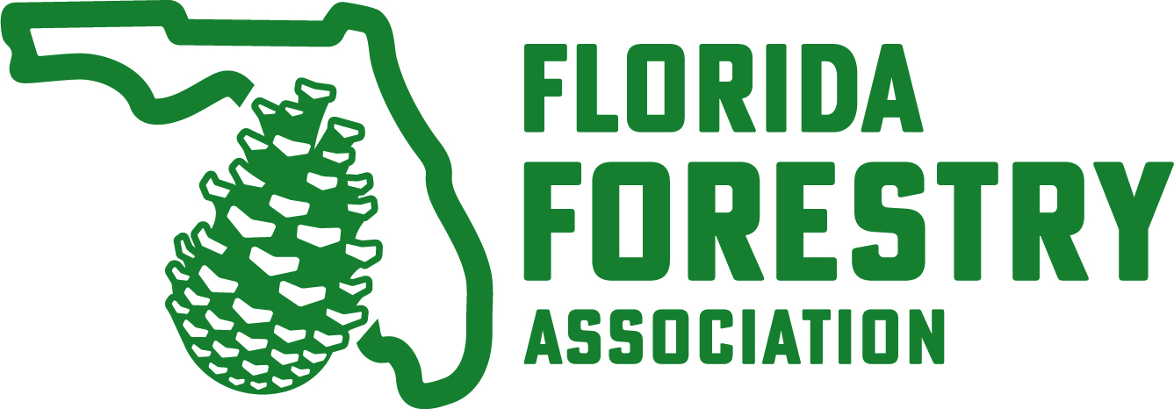
Annual Meeting & Trade Show
August 27 – August 29, 2024
Omni Amelia Island Resort
Amelia Island, FL

Sponsor Benefits:
$10,000 – Platinum Sponsor
• Exclusive sponsorship of one of the following:
- Wednesday morning Golf Tournament
- Thursday morning Awards Breakfast
- Thursday evening Dinner
• Logo recognition in Annual Meeting promotions
• Company logo on website
• On-stage recognition and speaking opportunity
• Reserved Sponsor Table
• Exclusive sponsor signage specific to event sponsorship
• Back cover color ad* in Annual Meeting program (breakfast sponsor)
• Inside back cover color ad* in Annual Meeting program (dinner sponsor)
• Inside front cover b/w ad* in Annual Meeting program (golf sponsor)
• Opportunity to provide promotional items at sponsor table in meeting foyer
• Sponsor level recognition on website, Facebook page, event promotions, program and signage

$6,000 – Gold Sponsor
• Exclusive sponsorship of one of the following:
- Tuesday evening Icebreaker Reception
- Wednesday evening Welcome Reception
- Thursday afternoon Trade Show Social
- Thursday evening Reception (before dinner)
- Thursday evening Reception (after dinner)
- Refreshments Tue/Wed/Thu inside Trade Show
- Audio-Visual Technology
- Golf Beverage Cart
• Logo recognition in Annual Meeting promotions
• Company logo on website
• Exclusive sponsor signage specific to event sponsorship
• Half page b/w ad* in Annual Meeting program
• Sponsor level recognition on website, Facebook page, event promotions, program and signage

$3,500 – Silver Sponsor
• 1/6 page b/w ad* in Annual Meeting program
• Sponsor level recognition on website, Facebook page, event promotions, program and signage

$2,000 – Bronze Sponsor
• Business card b/w ad* in Annual Meeting program
• Sponsor level recognition on website, Facebook page, event promotions, program and signage

$1,000 – Friend of Forestry Sponsor
• Sponsor level recognition on website, Facebook page, event promotions, program and signage

$250 – Patron Sponsor
• Sponsor level recognition on website, Facebook page, event promotions, program & signage
*Annual Meeting program ad to be provided by sponsor. Specifications will be provided.

